BBST Lecture 2

1.An activity aimed at evaluating an attribute of capability of a program or system and determining that it meets its required result .. testing is the measurement of software quality “ Bill hetzel (complete guide to software testing )

**2.Software testing is an empirical , technical investigation conducted to provide stakeholders with information about quality of the product or service under test .**

3.Karl popper argued that experiments designed to confirm an expected result are of fare less scientific value than experiments designed to disapprove the hypothesis that predicts the expectations **.**

4.Design the experiment to challenge what you believe

5.Design experiments that are likely to fail if you are wrong

6.Dont run the same set of tests again and again (regression testing )

7.We should test each feature more harshly than last time( **testing with different platforms , or with more complex data or with other features** )

Many different information objectives

* Find important bugs
* Assess the quality of the product
* Help managers assess the quality of the project
* Help managers make release decisions
* Block premature product release
* Help, predict and control product support costs
* Check interoperability with other products
* Find safe scenarios to use the product
* Assess conformance to specifications
* Certify the product meets a particular standard
* Ensure the testing process meets accountability standard
* Minimize the risks of safety lawsuits
* Help clients assess their products quality and testability
* Help clients evaluate their process and suggest ways to improve them
* Evaluate the product for a third party

**Your mission is to answer the question “why are you testing ?”**

**Testing strategy** :The set of ideas that guide your test design

**Testing logistics** :The set of ideas that guide your application of resources

**Testing plan** :The combinations of strategy , logistics and project risk management

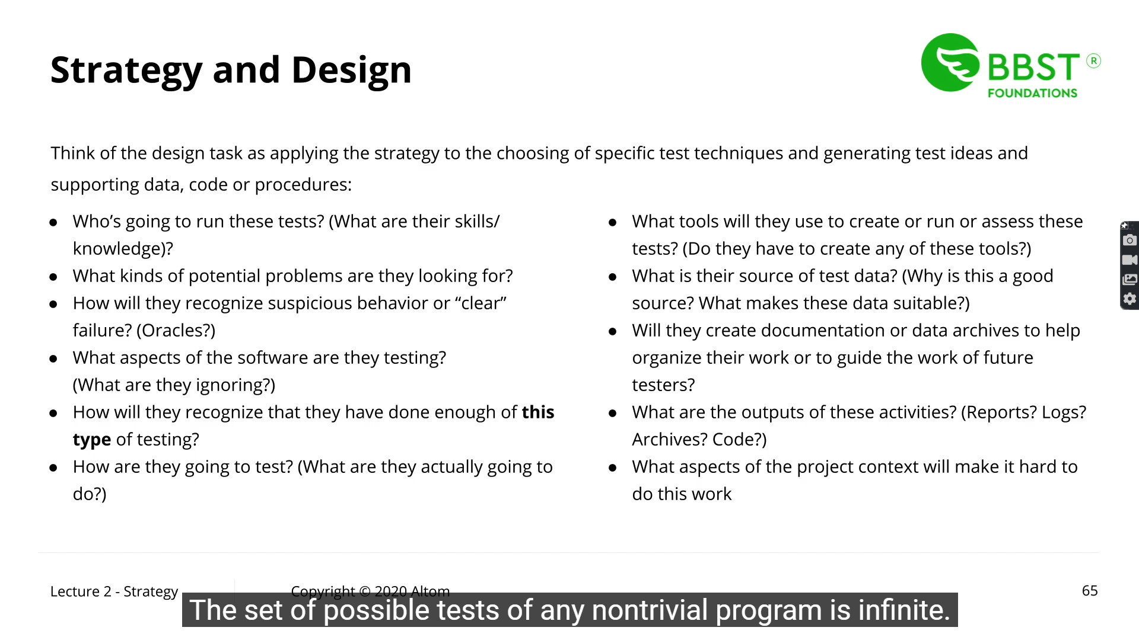

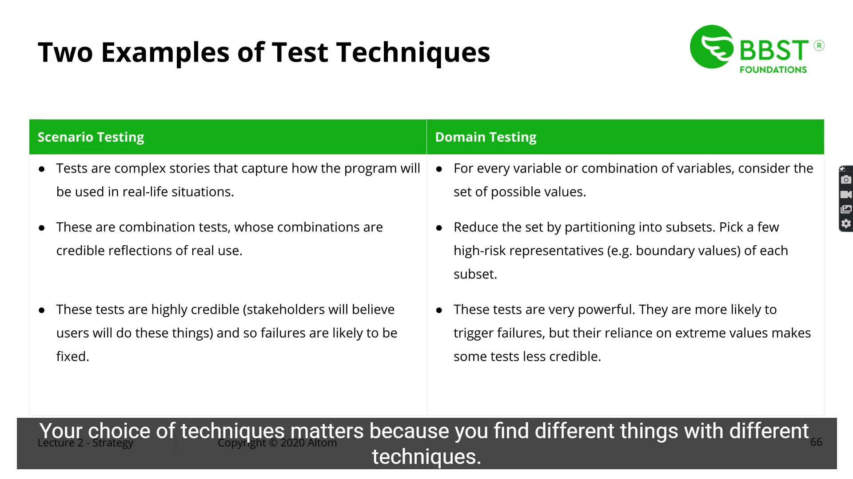

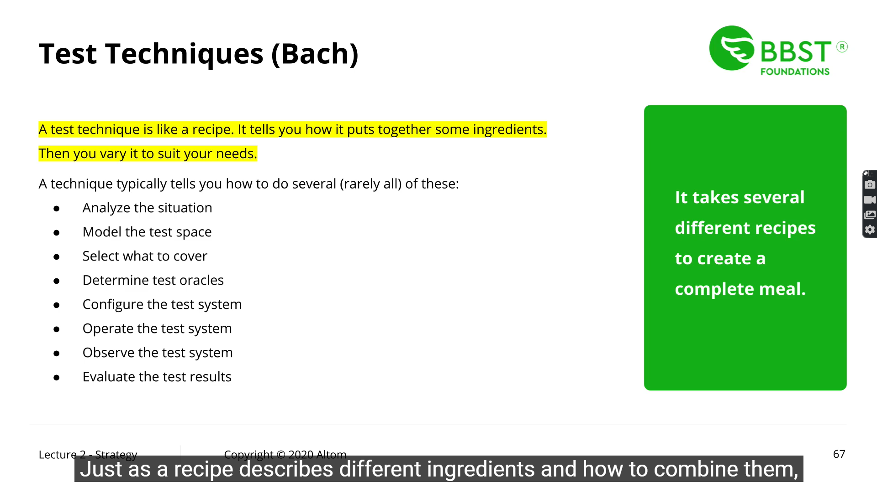

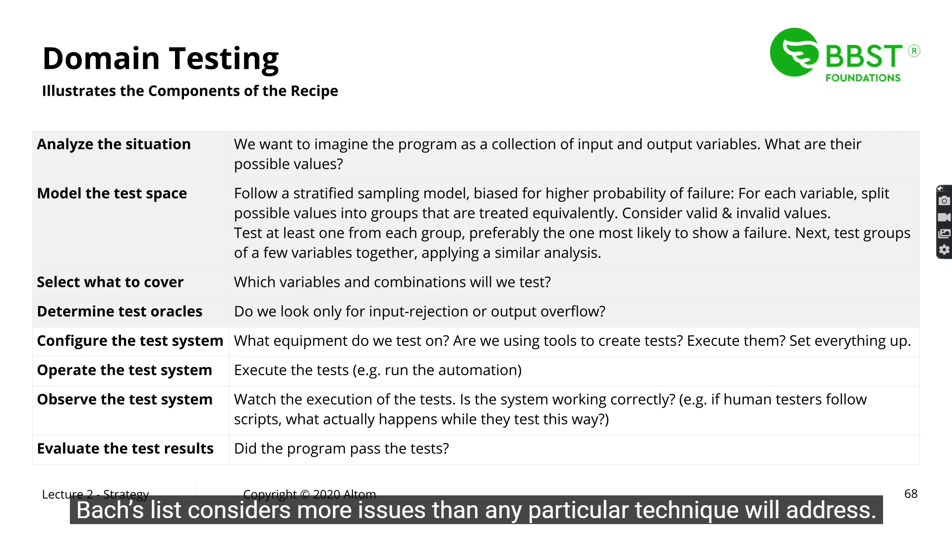

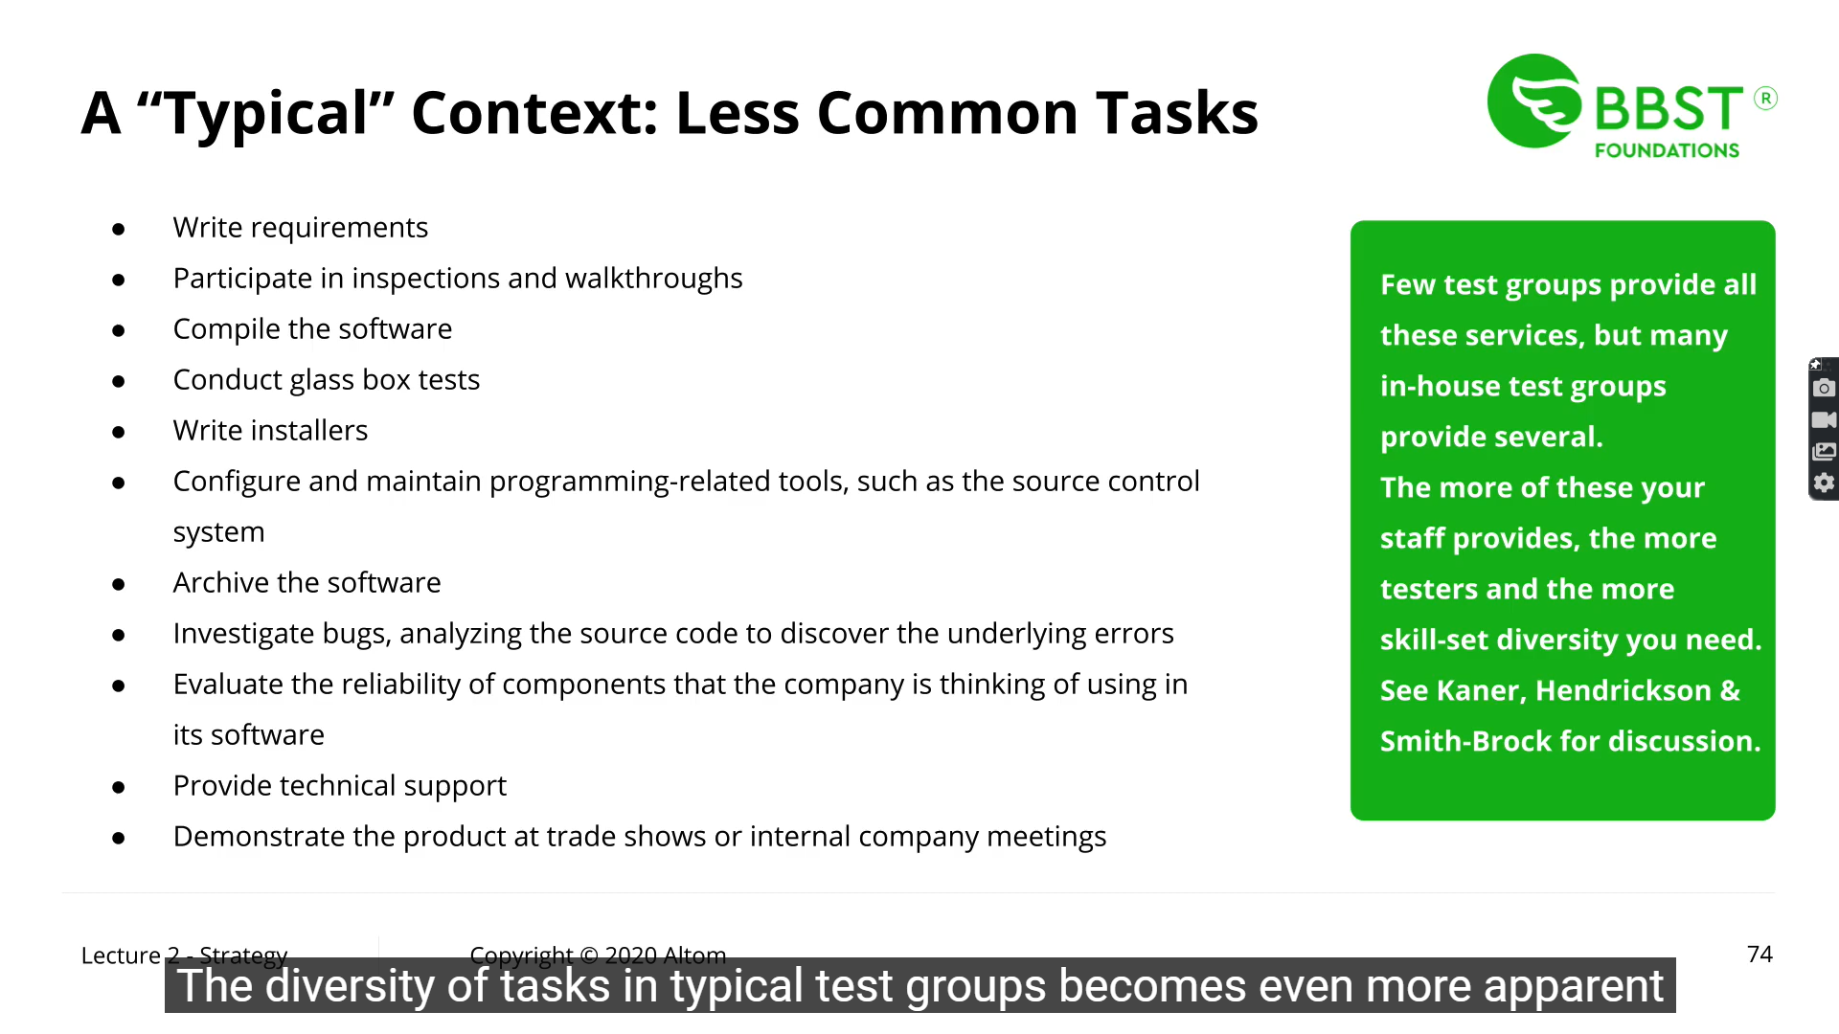

Software tester role in IT organization

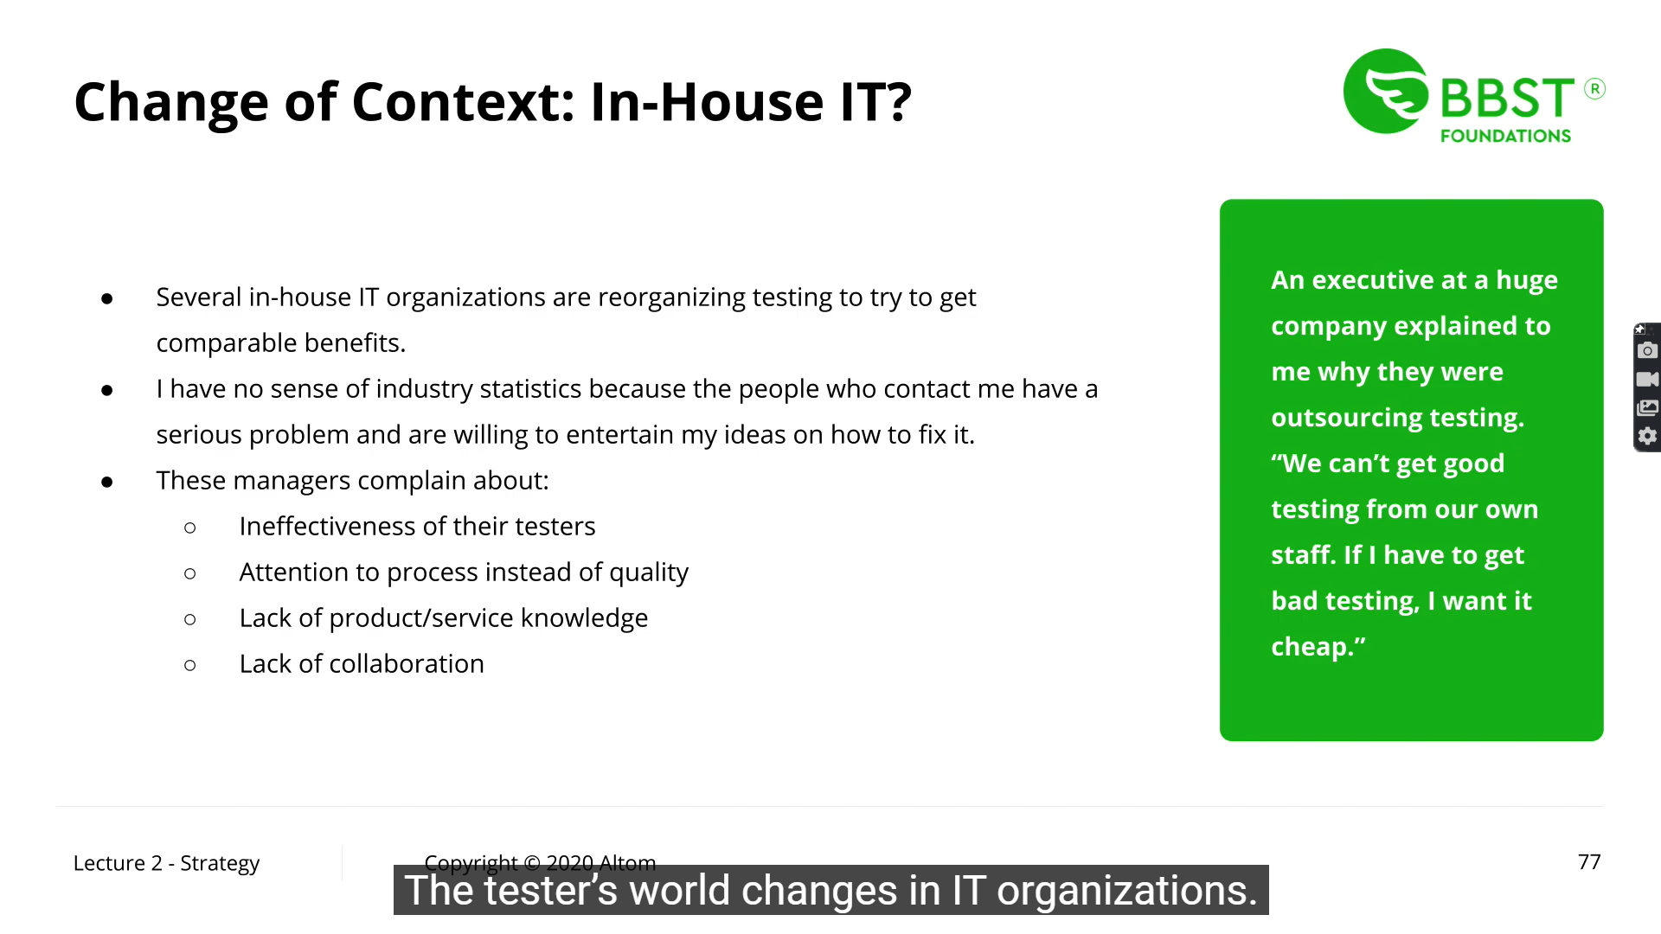

Independent test organizations

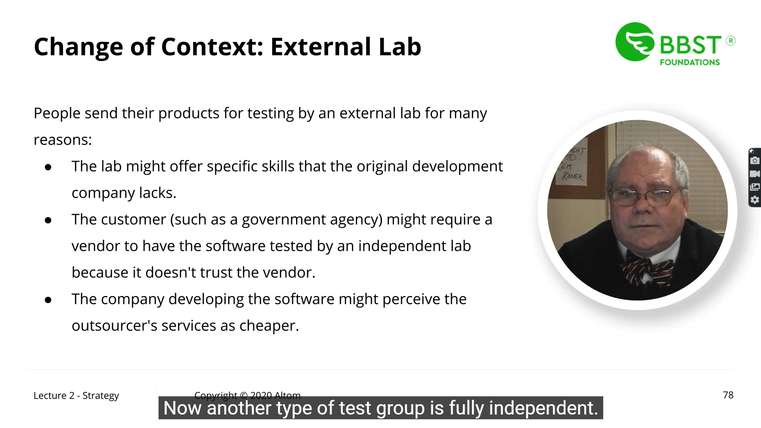

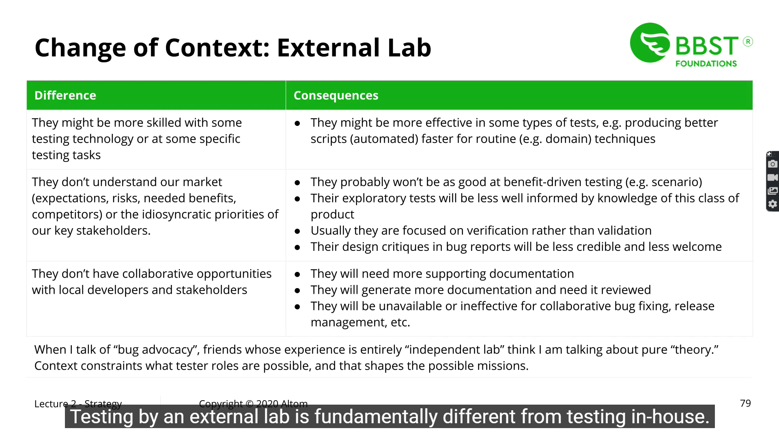

Verification : Asking whether a product was built correctly

Validation : whether the right product was built (if the tester claims that the product will not serv the user’s purpose , then it’s the process of validation)